2200032991

WEEK-3 TASK-3

**Exercise 4: Creating and Configuring a Maven Project**

1. **Create a New Maven Project:**

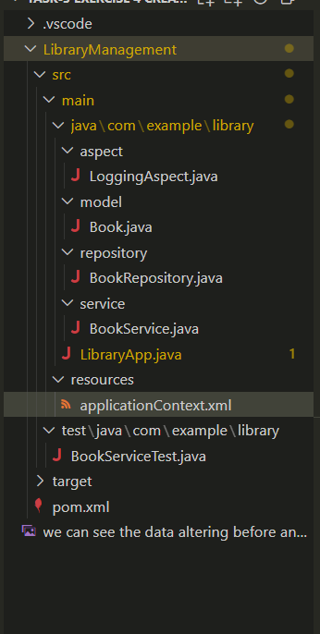

1. **Add Spring Dependencies in pom.xml:**

 <dependency>

      <groupId>org.springframework</groupId>

      <artifactId>spring-context</artifactId>

      <version>${spring.version}</version>

    </dependency>

<dependency>

      <groupId>org.springframework</groupId>

      <artifactId>spring-webmvc</artifactId>

      <version>${spring.version}</version>

    </dependency>

**3.Configure Maven Plugins:**

* + Configure the Maven Compiler Plugin for Java version 1.8 in the pom.xml file.

1. <properties>
2. <java.version>1.8</java.version>
3. <spring.version>5.3.39</spring.version> <!-- last Spring 5 LTS that supports Java 8 -->
4. <maven.compiler.plugin.version>3.12.0</maven.compiler.plugin.version>
5. <maven.exec.plugin.version>3.2.0</maven.exec.plugin.version>
6. <maven.surefire.plugin.version>3.2.5</maven.surefire.plugin.version>
7. <junit.jupiter.version>5.10.2</junit.jupiter.version>
8. </properties>

Example taken outputs

